

W6 PRACTICE
FORMS & INPUTS

 What are the objectives for this session?
- Learn and use various HTML form input types
  - text, checkbox, radio, dropdown, text area, range, color, selector etc.

- Apply basic CSS styles to enhance the appearance of form inputs
  - borders, colors, padding, margins etc.

- Use: :focus :hover : checked :checked :indeterminate CSS pseudo-classes

 How to start?
✔ Download the start code from the LMS
✔ Open the folder in VS Code

 How to submit your work?
✔ Push your final code on your GitHub repository
✔ Then attach the GitHub path to the MS Team assignment and turn it in

 Are you lost?
You can read the following documentation to be ready for this practice:
- Guide - WC3 School
- The Form element
- HTML Forms



PART 1: LEARN – 45 MIN
- Read or watch resources on internet to learn about HTML Inputs: Guide - WC3 School
The Form element HTML Forms

- Complete the bellow table.

INPUT TYPE | USAGE | EXAMPLE
Text | defines a one-line input field for text input | <input type="text">
radio | Define a radio button for selecting one of many choices | <input type="radio">
checkbox | Defines a checkbox for selecting zero or more of many choices | <input type="checkbox">
range | Create a slider to select a numeric value within a range | <input type="range" min="0" max="100">
submit | Define a submit button for submitting the form | <input type="submit">
textarea | Used to get input long text content. | <textarea rows="4" cols="30"></textarea>
select | Used to create a drop-down list. | <select><option>Option 1</option></select>
color | Allow the user to choose a color using a color picker | <input type="color">
file | Allows the user to upload a file | <input type="file">

- Read or watch resources on internet to learn about Inputs styling: https://www.w3schools.com/css/css_form.asp

- Complete those mini challenges by writing your code on bellow table:

MINI CHALLENGES | YOUR CODE (HTML + CSS)
Highlight the input field when it is focused | <input type="text" class="focus-input" placeholder="Focus me">  <style>  .focus-input:focus {  outline: none;  border: 2px solid #4A90E2;  background-color: #eef6ff;  }  </style>
Change the button background color on hover | <button class="hover-btn">Hover me</button>  <style>  .hover-btn {  background: #4A90E2;  color: white;  padding: 10px 20px;  border: none;  cursor: pointer;  }  .hover-btn:hover {  background: #1f6acb;  }  </style>
Create a search bar with rounded corners and a shadow effect | <input type="text" class="search-bar" placeholder="Search...">  <style>  .search-bar {  width: 250px;  padding: 10px 15px;  border-radius: 25px;  border: 1px solid #ccc;  box-shadow: 0 2px 6px rgba(0,0,0,0.2);  outline: none;  }  </style>
Display a different style when the checkbox is checked | <label>  <input type="checkbox" class="style-check">  Check me  </label>  <style>  .style-check:checked {  accent-color: #4A90E2;  }  </style>
HARD!  Style a checkbox to have three states: unchecked, checked, and indeterminate.  TIP  Use CSS pseudo-classes (:checked and :indeterminate)  for styling. | HTML  <input type="checkbox" id="tri" class="tri-checkbox">  <button onclick="toggleState()">Next State</button>  <script>  function toggleState() {  const box = document.getElementById("tri");  if (!box.checked && !box.indeterminate) {  box.indeterminate = true;  }  else if (box.indeterminate) {  box.indeterminate = false;  box.checked = true;  }  else {  box.checked = false;  }  }  </script>  CSS  .tri-checkbox {  width: 20px;  height: 20px;  appearance: none;  border: 2px solid #444;  border-radius: 4px;  cursor: pointer;  position: relative;  }  .tri-checkbox:checked {  background-color: #4A90E2;  border-color: #4A90E2;  }  .tri-checkbox:checked::after {  content: "✔";  color: white;  font-size: 16px;  position: absolute;  left: 3px;  top: -1px;  }  .tri-checkbox:indeterminate {  background-color: #f5a623;  border-color: #f5a623;  }  .tri-checkbox:indeterminate::after {  content: "";  position: absolute;  background: white;  width: 12px;  height: 3px;  left: 2.5px;  top: 8px;  border-radius: 1px;  }

- Some groups will be selected to present and explain their work to the whole class

PART 2: PRACTICE – 45 MIN
You need to reproduce – as close as possible - the bellow table. Before coding, identify the following point:
- Elements: What are the different inputs you will need?

- Layout: what kind of CSS layout do you need? Why?

- Input styling: What are the styles you need to apply on your inputs?
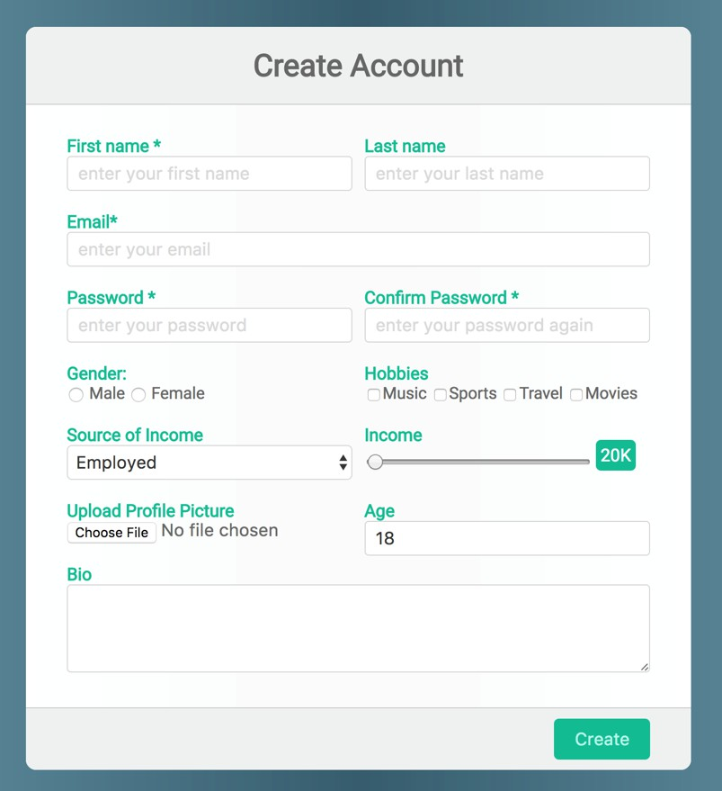
Be as close as possible from this mock up

